Sequence of processing for substrate mapping projects using SAMBUCA
Magnus Wettle, Janet Anstee and Vittorio Brando

Deglinting

Well documented in the Scott Reef Report (Quickbird_bathymetry_ScottReef.pdf).

Is typically done prior to atmospheric correction.

Code QBdeglint.pro
Input image must be BSQ format with DN values
Step 1: Select several optically deep water ROIs.

Step 2: Create scatterplots for each band vs the NIR band in excel to determine their relationship. The slope is used in the deglint code and implemented to the image.

Step 3: Determine the baseline NIR DN value (on a deep water relatively glint free region), where a good rule of thumb is

R_{NIR} baseline = mean – SD.

The choice of area and R_{NIR} baseline value may vary with interpretation of the data. The principle is to identify a DN NIR value that corresponds to ZERO water leaving radiance (given a certain level of noise).

Step 4: Set the slope for each band and the baseline NIR in QBdeglint.pro.

Decontiguer Masker

1. Shallow water mask

This code masks part of the image where the substrate contaminates the NIR. It has to be applied when de-glinting was necessary because the NIR signature may be caused either by glint on the surface or by the substrate in very shallow water. A pixel was masked if the surrounding pixels all had higher NIR values than the mean minus 1 SD:

NIR_thresh = NIR_{mean} – NIR_{SD} and

To objectively determine a threshold for the cut-off point between deep water sun glint and substrate NIR signal, the mean and standard deviation of the NIR DN values are determined for deep open waters

masked pixel DN > NIR_thresh > pixels not masked

In the code, you need to set

NIR_thresh (in DN)
min_num_count

The latter is the minimum number of pixels surrounding a central pixel that have to have a DN value > NIR_thresh for the central pixel to be masked. Default is all surrounding pixels (in a 5 x 5 window).

2. Optically deep water mask

if the bottom substrate is not contributing to the measured remote sensing signal, bathymetry cannot be estimated

This code masks optically deep water for all bands. The Scott Reef examples has used the Green QB band (assumed to be greatest DOP) and masked out all pixels lower than the Green bands mean plus 1 SD:

Green_thresh = Green_{mean} + Green_{SD}

Masked pixel DN< Green_thresh < pixels not masked

Need to set the Green_thresh (in DN) and the min_num_count in the code (see NIR description above).

Get Noise
Select optically deep, most homogeneous region. This is typically done on atmospherically corrected image.

In ENVI, run Get_noise and save the file in the SAMBA/input2007/NEDR folder – then SAMBUCA will have the file in the list of options. (Make sure that the ‘.lib’ extension has been appended to the noise library file).

DVR (Data Volume Reduction)

group the image data into a set of spectrally distinct classes. If two spectra differ by less than the noise levels in the data, they can be grouped as one class with a relatively minimal loss of information. The advantage of grouping pixels into distinct classes is that each class (which can contain a large number of pixels) is represented by one spectrum.

Code: NEDR_imagecluster.pro
To run:
Set cluster_radius = 2 (this is the number of noise levels – typically set to 2, e.g. Scott Reef)

Code Outputs:

Spectral library (of all classes in image)
Classes Image (location of each class in image)
*_FULL.img (each spectra remapped to location in image)

-
To qualitatively see if the DVR was successful use the *_FULL.img to compare the replication of information with the input file (original image) using a similar stretch. Also, you can compare the depth estimate by SAMBUCA for a subset of the original image vs. the corresponding subset of the DVR’d library. This involves running SAMBUCA on the DVR’d library, mapping it back to an image (using labels_to_image), see below), and extracting a subset that matches the area processed by SAMBUCA on the original image. A scatter plot then does the job.

Note that SAMBUCA can typically only be run on a very limited sample subset (100 x 100?) as it is computationally demanding.

SAMBUCA

Code: sambuca_wid.pro

To run:
Select input envi file (either *.img or *.lib)
Select the noise equivalent file. (Before this the NEDR needs to be estimated: Run Get noise in envi and save the file in the sambuca/NEDR folder – then SAMBUCA will have the file in the list of options –see GET_NOISE above)

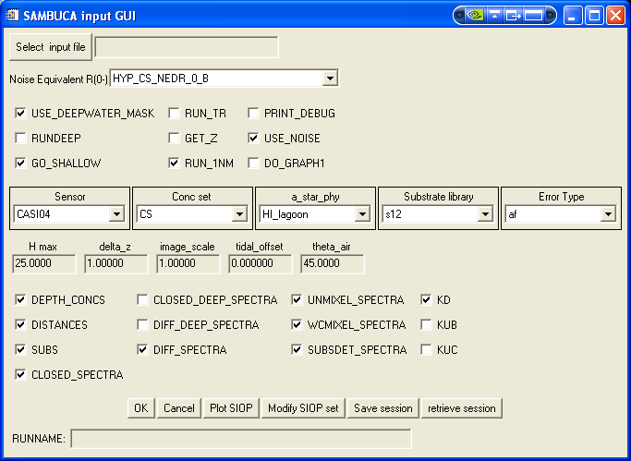
OPTIONS
Use_Deepwater_Mask
If the difference between the optically deep water and the spectra is less than given value (0.005) then it is given a label (500).

Rundeep
Assumes spectrum is from optically deep water (ie no substrate influence) and solves for the water constituents.

Go_shallow
Will achieve the shallowest possible depth retrieval within one NEDR of the solution (modelled spectrum). This is used to avoid greatly varying/random depth estimates in optically deep areas.

Run_TR
Chl & CDOM are locked (with starting values), and only TR is solved for in water colum.

Get_Z
Requires a previously derived SAMBUCA bathymetry estimate (can even use a *.lib)
NB: Need to manually extract the bathymetry band from the *conc_depth.img as SAMBUCA only wants a single band image.

Run_1nm
Resamples everything to 1nm, then just before spectral match (typically ‘alpha f’) is estimated, it resamples back to sensor bands.

Print_debug

Use_noise
Uses the specified NEDR(0-) in order to express the spectral closure in levels of noise quanta, i.e. spectral closure is attempted to within one noise level.

Do_Graph
Displays the SAMBUCA spectral matching (not currently working)

SENSOR
Select correct sensor.

CONC SET
Select the relevant *.sav file, first created in the ‘Modify SIOP set option at the bottom row of the GUI’

A_STAR_PHY
Select the relevant *.sav file, first created in the ‘Modify SIOP set option at the bottom row of the GUI’

SUBTRATE LIBRARY
Select the relevant *.lib file. (The UQ02.lib contains a dark and light coral reef substrate and is a good starting point to first extract the bathymetry)

ERROR TYPE
Alpha f is mostly used

Hmax
Maximum depth that allows sambuca to run to (generally set to deeper than the maximum known depth)

Delta_z
This is the +/- range SAMBUCA allows for the depth when using a fixed bathymetry (only relevant when using the Get_z option)

Image_scale
Rescales values in the image

Tidal offset
Expressed in metres from a baseline.

Theta_air
The sun zenith angle (in degrees)

Outputs selection

Depth_concs
CHL
CDOM
TR
Z
Fval
IOD

Distances
Alpha f
Alpha
F

Subs
The no. of subs as specified in the input *.lib with their % coverage (max of 2 possible substrates per pixel)

Closed_spectra
SAMBUCA’s best attempt at simulating the spectra, i.e. R(0-) modelled

Closed_deep_spectra
The deep water component of R(0-) modelled.

Diff_deep_spectra
Difference between deep water component of R(0-) modelled & the R(0-) input (either *.img or *.lib)

Diff_spectra
Difference between the R(0-) modelled and R(0-) input (either *.img or *.lib)

UNMIXEL SPECTRA
Mixels created from the 2 substrates with no water column (ie ~bottom albedo)

WCMIXEL_SPECTRA
Theory: if you have solved/estimated all the water constituents and depth, then you should be able to exactly solve for A (bottom albedo)…..

In other words, WCMIXEL is the adjusted mixel required to provide a perfect solution given the previously solved for depth+ water column properties.

(This didn’t work for Coringa NE)

SUBSDET_SPECTRA
This is the spectrum of the contribution of the bottom substrate to the R(0-) modelled, expressed in noise level quanta: R(0-)modelled – R(0-)modelled deep

K_{D} per pixel
K_{UB} per pixel
K_{UC} per pixel

LABELLING

Code: labels_to_image4.pro
As it now stands, the code expects all the following outputs of sambuca to be there otherwise the code crashes (can of course be modified in code:

_closed_deep_spectra
_closed_deep
_distances
_diff_spectra
_unmixel_spectra
_wcmixel_spectra
_depth_concs

To run
Select the sambuca output substrate (from the DVR)
Select the corresponding output CLASS image (from the DVR)

The code will automatically create images with labelled DVR classes: substrates and all the other sambuca outputs labelled correctly on a full-sized image.

